Generic Immunization Table

 |  | Date Received | Return Date
Age | Antigen | DD / MM / YY | DD / MM / YY

Birth BCG
/ /
/ /

OPV-0
/ /

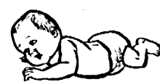6 weeks DTP-HepB-Hib 1
/ /
/ /

PCV 1
/ /

OPV 1
/ /

Rota 1
/ /

10 weeks DTP-HepB-Hib 2
/ /
/ /

PCV 2
/ /

OPV 2
/ /

Rota 2
/ /

14 weeks DTP-HepB-Hib 3

PCV 3
/ /

/ /
/ /

OPV 3
/ /

IPV / /

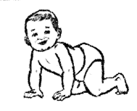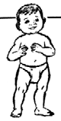9 months Measles-Rubella 1 / /

18 months Measles-Rubella 2 / /
/ /

8 Integrated Home-based Records: Assuring Immunization Format and Function

